**Huda Husain Petkar**

**M. Sc DS AI || L017 || ADBMS**

**Practical - 7**

**Date: 21.02.25**

**Topic: Sharding in MongoDB**

1. **Create the necessary directories**

mkdir C:\data\db\shard1

mkdir C:\data\db\shard2

mkdir C:\data\db\config

mkdir C:\data\db\mongos

mkdir C:\data\log\shard1

mkdir C:\data\log\shard2

mkdir C:\data\log\config

mkdir C:\data\log\mongos

echo "" > C:\data\log\shard1\mongod.log

echo "" > C:\data\log\shard2\mongod.log

echo "" > C:\data\log\config\mongod.log

echo "" > C:\data\log\mongos\mongos.log

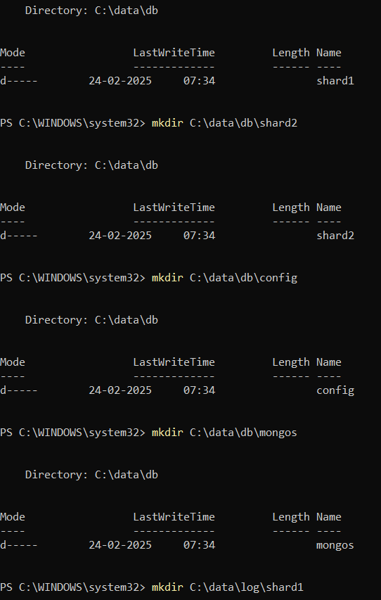

1. **Start the Shard Servers:**

*Command Prompt 1 (Shard 1):*

mongod --replSet rs1 --shardsvr --dbpath C:\data\db\shard1 --logpath C:\data\log\shard1\mongod.log --port 27017

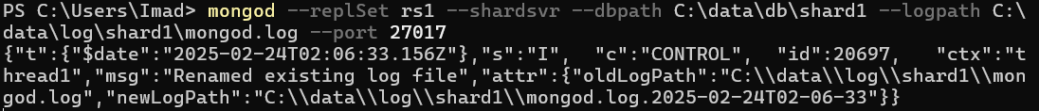

*Command Prompt 2 (Shard 2):*

mongod --replSet rs2 --shardsvr --dbpath C:\data\db\shard2 --logpath C:\data\log\shard2\mongod.log --port 27018

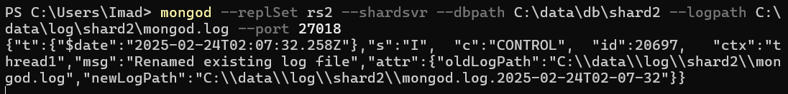

1. **Initialize the Shard Replica Sets:**

*Command prompt 3:*

mongosh --port 27017 --eval "db.adminCommand('replSetInitiate')"

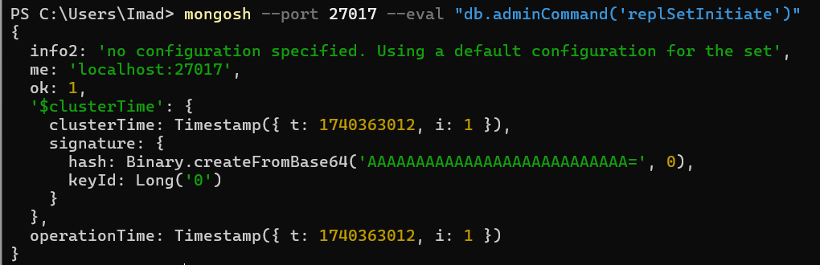

*Command prompt 4:*

mongosh --port 27018 --eval "db.adminCommand('replSetInitiate')"

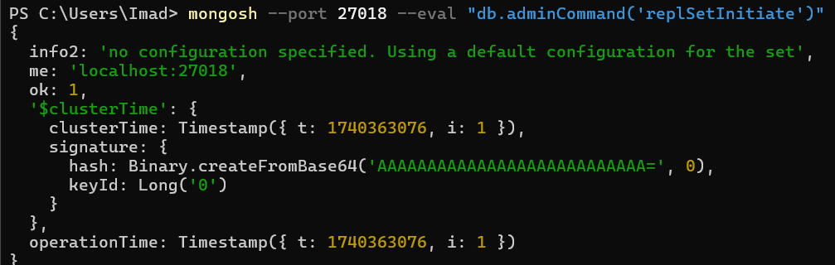

1. **Start the Config server**

*Command prompt 5:*

mongod --replSet csRS --configsvr --dbpath C:\data\db\config --logpath C:\data\log\config\mongod.log --port 27019

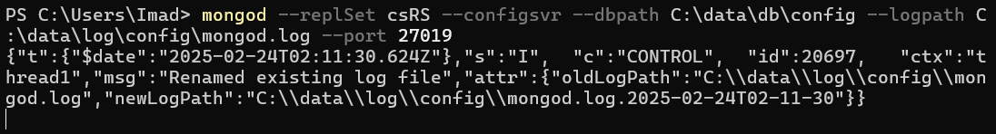

1. **Initialize the Config Server Replica Set:**

*Command prompt 6:*

mongosh --port 27019 --eval "db.adminCommand('replSetInitiate')"

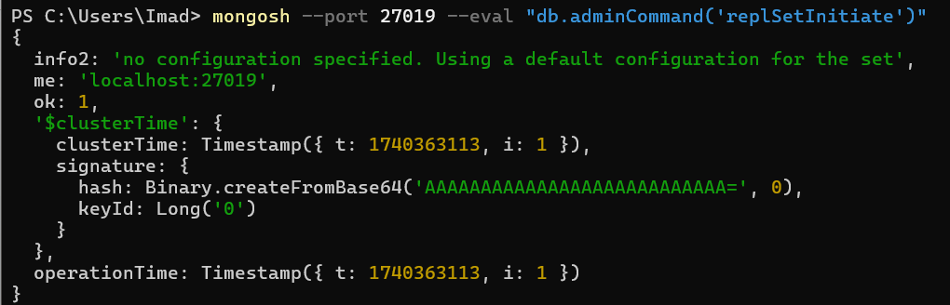

1. **Start the mongos Router:**

*Command prompt 7:*

mongos --configdb csRS/localhost:27019 --logpath C:\data\log\mongos\mongos.log --port 27020

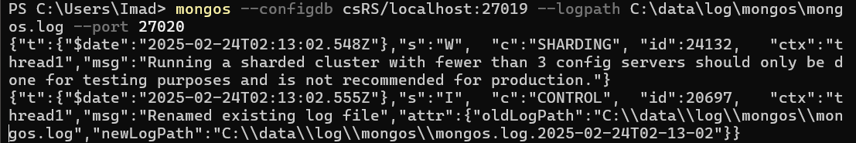

1. **Connect to the mongos Router and Perform Sharding Operations:**

*Command Prompt 8 (MongoDB Shell):*

mongosh --port 27020

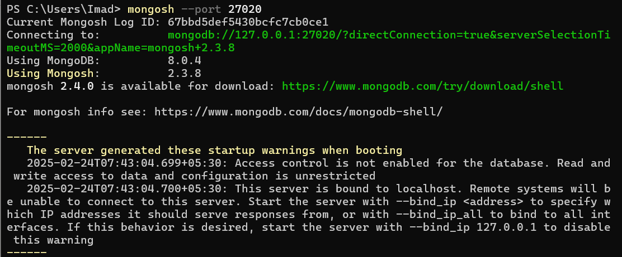

*Now, within the same cmd window “[direct: mongos] test> “will appear*

*Then run the foll cmds*

sh.addShard("rs1/localhost:27017")

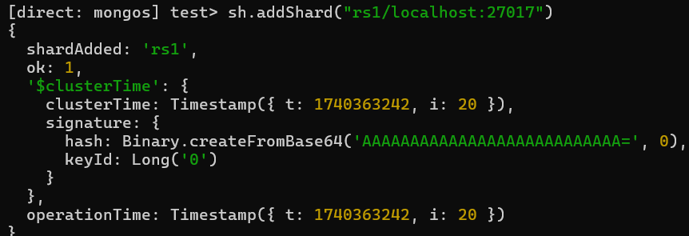

sh.addShard("rs2/localhost:27018")

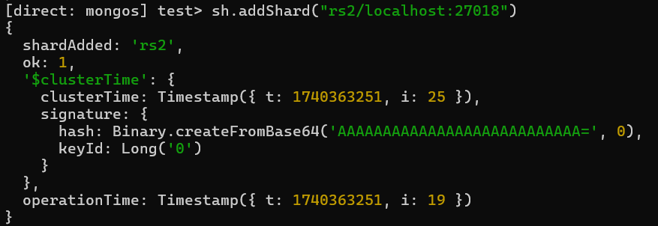

*Now we will create a database & collection →*

use mydatabase

db.createCollection("users")

sh.enableSharding("mydatabase")

sh.shardCollection("mydatabase.users", { _id: 1 })

*After the last command (sh.shardCollection(...)) executes successfully, our collection will be sharded.*